RECOMENDED BRUSHES FOR YOUR DOG
www.groomers-oneline.com
Tel: 08452307997
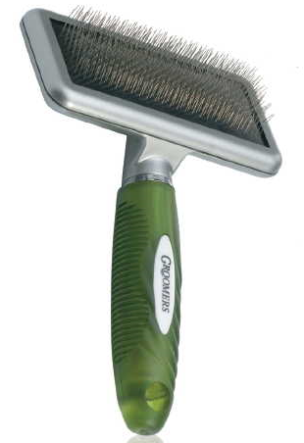
Groomers Medium Slicker Brush

http://www.groomers-online.com/product.php/900/groomers-medium-slicker-brush
Product Code: GMS01 Price £6.99
--------------------------------------------------------------------------------------------------------------
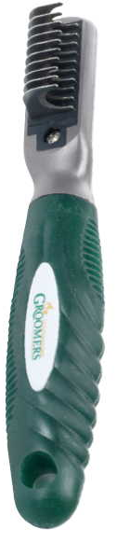
Groomers Mattie
http://www.groomers-online.com/product.php/2190/groomers-mattie-

Product Code: GF011 Price £7.99
----------------------------------------------------------------------------------------------------------------
Groomers Moulting Comb
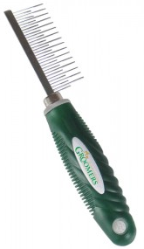
http://www.groomers-online.com/product.php/3468/groomers-moulting-comb
Product Code: GMTC Price £5.90

